**Reinforcing Liquidity Concepts & Price Delivery**

Reinforcing Liquidity Concepts & Price Delivery

External Range Liquidity

The current trading range will have Buy Side Liquidity above the range or High. The current trading range will have Sell Side Liquidity below the range or Low.

Runs on Liquidity - seek to pair orders with the pending order liquidity - Liquidity Pools. External Range Liquidity Runs can be Low Resistance or High Resistance in nature.

E Internal Range Liquidity

When current trading range is likely to remain - Liquidity Voids will fill in - Gap Risk. When current trading range is likely to remain - Fair Value Gaps will fill in - Gap Risk. Orderblocks inside the trading range will be populated with new Buy & Sell orders.

Market Maker Buy & Sell Models will form inside trading ranges.

Everytime when the market makes a new range, mark the high and the new low and youll be trading in the range, so if you trade at a bearish orderblock thats going to be a return to internal range liquidity but youre going to be looking for external range liquidity to exit on

ICTs entries are mostly entries on internal liquidity and exits on external liquidity

Once you understand where the HTF wants to go you can frame your setups to lower timeframe We can run external range liquidity on the daily but on the monthly it can still be internal

When we understand where the weekly and monthly are willing to trade to, on the daily it creates a recipe for low resistance liquidity runs. So when we expect a high to go because of the monthly and weekly bias, then these highs are a low resistance liquidity run. Because price has an agenda. So with this idea we can classify wether its a high resistance or low resistance liquidity run

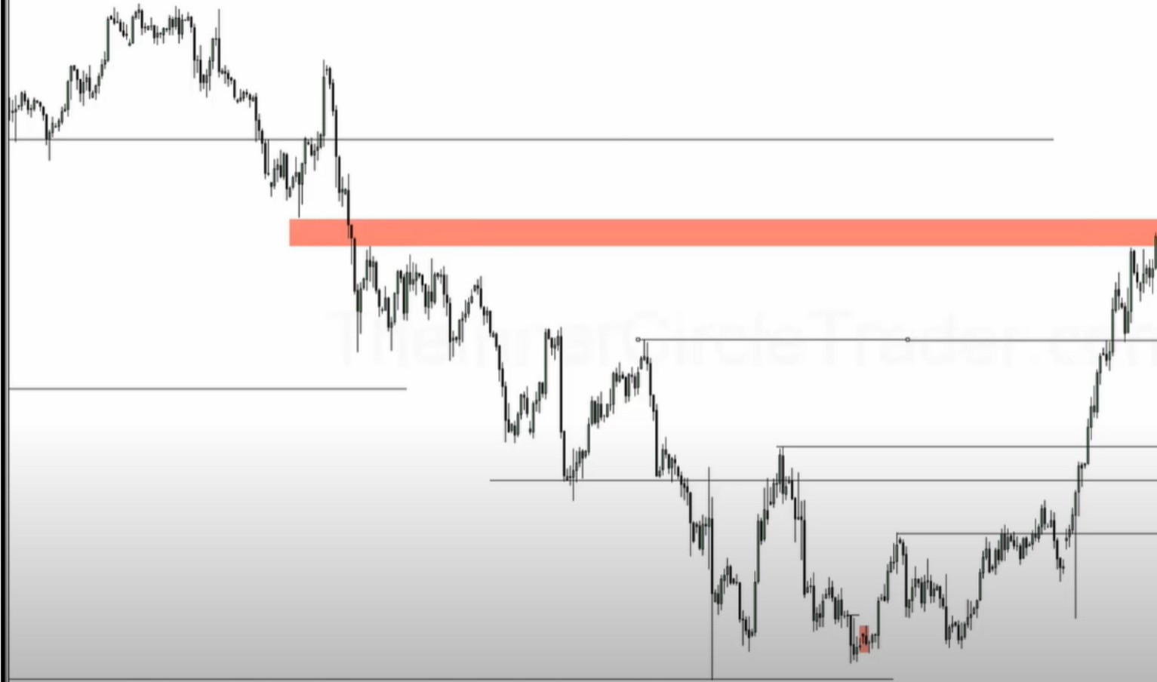

So on the 4h you can see we have very little resistance running trough the highs, because its framed on low resistance liquidity runs based on the HTF monthly

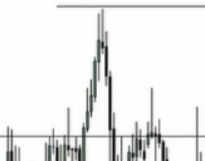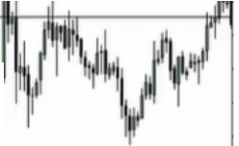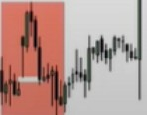

*J*

I

1 11:

I *I*

II ffl

/

I w

I /

*V'* \

This is how ICT know which stops will be taken, he uses the HTF institutional orderflow to frame out where internal range liquidity is and external range liquidity is, where is the buy stops, what kinda entry am i using and how is it aligned with the HTF

He doesnt use the low where there is a consolidation, he uses the energetic low, the low with the red arrow is the one he uses

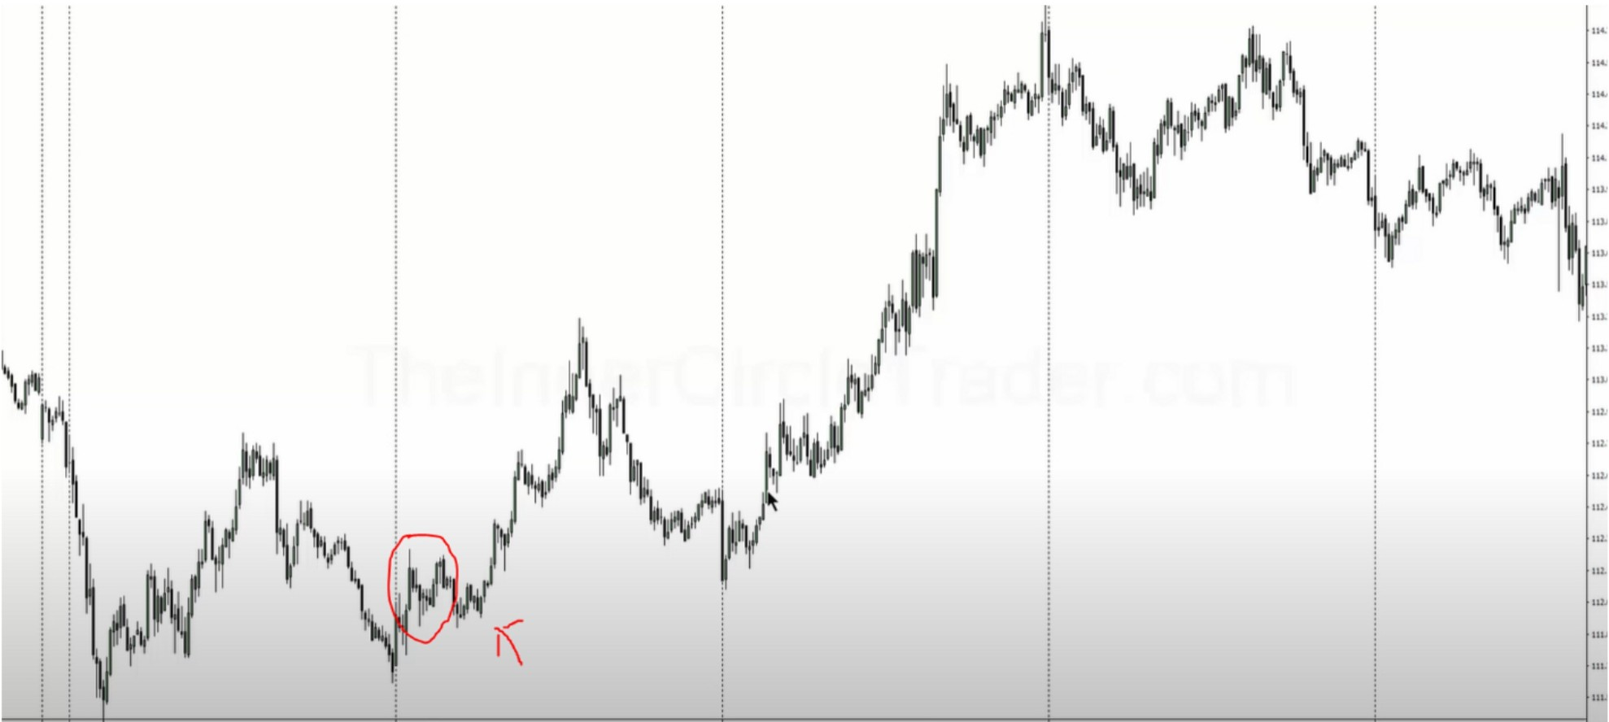

You're looking to buy with internal range liquidity or a bullish orderblock inside the previous range, and try to take profit at an old external high or above it, while you're in sync with the HTF directional bias based on institutional orderflow, looking at the monthly ranges and where it wants to trade to, in this case a monthly FVG

Since were bullish were looking for a displacement up and a retracement into an orderblock

If we dont see any ranges that create new buying opportunities then we can target lows, so go trough the market place and find the swing lows and wait for price to trade trough them on the

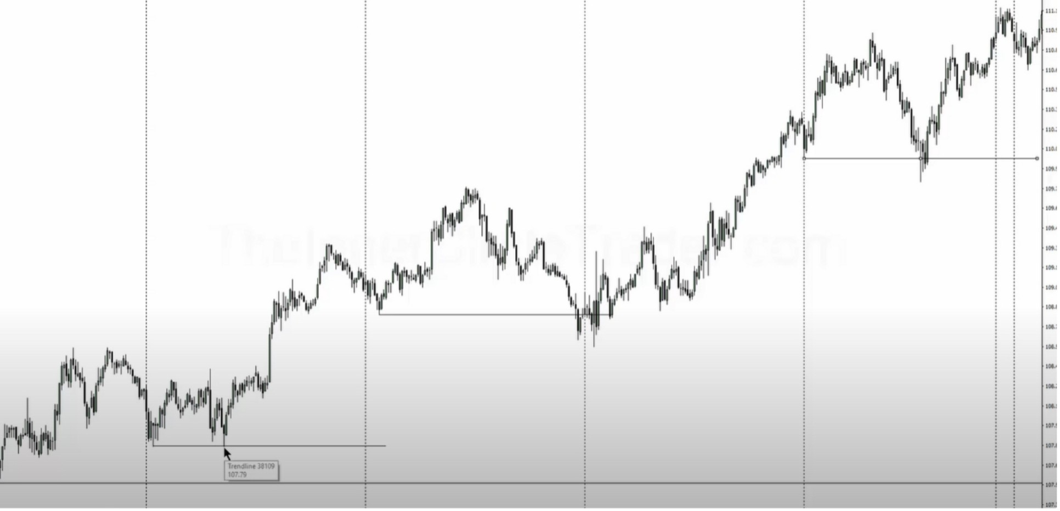downside, turtle soup

The type of trader youre going to be, is determined by which setups you find easy to see in the charts, either turtle soups, return to fair value inside the range, you don't have to find a setup everyday, you're looking for a setup once a week

If we know the HTF is bullish, our mind switched to okay where are the sell stops that theyre reaching for. Because if it wants to go higher and its dropping, were going to look for external range liquidity and once we trade below that and it tips it hand in the form of a quick reaction and see institutional sponsorship, wait for a bullish orderblock. The bullish orderblock wont always happen straight away. So its takes external range liquidity and then an internal range liquidity setup occurs as confirmation

This helps you define what a low resistance liquidity should be vs a high resistance run

The monthly chart is key to frame low resistance runs, if you cant frame where the monthly is going then drop down to the weekly

Study this

So every time we look to be a buyer from a bullish orderblock we expect the high to be taken out Trading against the HTF narrative and institutional orderflow is a high resistance liquidity run

Look at a monthly and weekly chart and look where were likely to go to, if theyre bullish we will look for longs on LTF in the form of turtle soups and orderblocks with expectation that the highs are going to get run

If the 1h returns back to an OB and the target high is only 20 pips away, ICT wouldnt take that trade You want to look at 40 pips minimum, depends on timeframe of course

The teachings in december cover framing the right swings and what orderblocks to use

You dont need the right swing if the range is big enough, thats the beauty of trading, you dont need to have every single direction right, get your 3r and your done

Pick a timeframe that fits your model and stick to it

The HTF will tell you if your trade is high or low resistance, developing your skills on the HTF is

important, everything is fractal. HTF charts are super important, thats where the money is. If you stay in the directional bias of the monthly weekly and daily then you have high odds of low resistance liquidity run

We will be using the concepts of external range liquidity & internal range liquidity in every december teaching to remove any confusion

Low resistance runs will give you immediate responses to your trades with low drawdown and fast actions, and thats what you want as a trader

Arjo I Twitter, lnstagram I Linktree

Linktree. Make your link do more.

, https://t.co/HhmmTN1fUI

JavaScript is not available.

*"JI* https://twitter.com/arjoio